**Deploying Remix Smart Contracts to Ganache Using Truffle**

**Steps:**

1. Install Node.js & npm

* Download and install Node.js(version 18)
* Verify the installation   
   node -v and npm -v

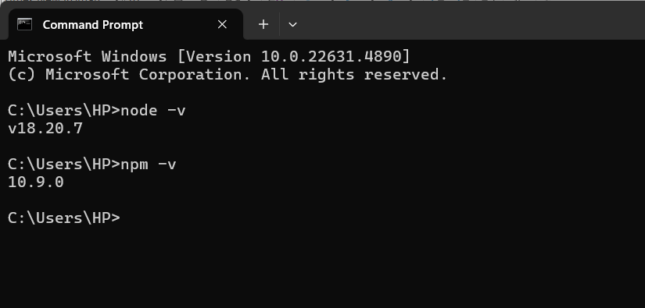

1. Install Truffle using npm

* To install Truffle, open your terminal and run:

npm install -g truffle

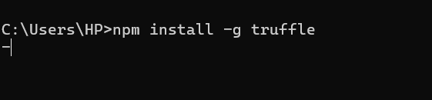

* Verify the installation  
   truffle version

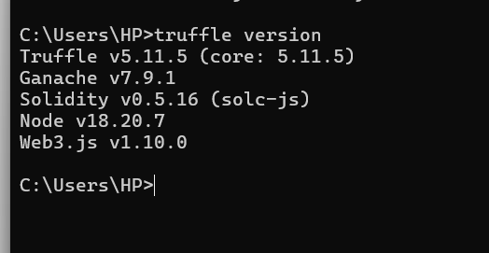

**Create a Truffle Project**

**Steps:**

1. Download the project from remix IDE

2. Initialize a Truffle project:  
 truffle init

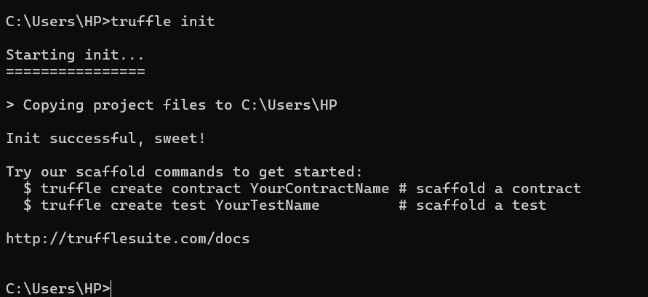

**Configuring Truffle to connect with Ganache**

**Steps:**

1.Open truffle-config.js in Vs code.

2. Modify the networks section to connect with Ganache:

|  |
| --- |
| module.exports = {  networks: {  development: {  host: "127.0.0.1", // Ganache runs on localhost  port: 7545, // Use 8545 for Ganache CLI  network_id: "*", // Match any network ID  },  },  compilers: {  solc: {  version: "0.8.20", // Ensure this matches your Solidity version  },  },  }; |

1. Save and close the file.

**Export a Smart Contract from Remix**

1. Open **Remix IDE** (Remix.ethereum.org).

2. Write a Solidity contract in Remix or use an existing one.

3. Compile the contract in Remix.

4. Click **Compile** and select the contract (e.g., MyContract.sol).

5. Click **ABI & Bytecode** and **Copy ABI**.

6. Save the contract to your Truffle project:

* Open the contracts/ folder in your Truffle project.
* Create a new file, e.g., MyContract.sol.
* Paste the **Solidity code** from Remix into this file.

7. Save and close the file.